Image Classification Using Convolutional Neural Networks (CNNs)

Internship Project Report
- Introduction
Image classification is a Computer Vision task in Artificial Intelligence that involves identifying and categorizing images into predefined classes. Convolutional Neural Networks (CNNs) are specialized deep learning models designed to automatically learn visual patterns such as edges, textures, and object shapes directly from image data.
In this project, an Enhanced CNN model was developed to classify images from the CIFAR-10 dataset. Various techniques such as data augmentation, batch normalization, dropout, and early stopping were implemented to improve model performance and reduce overfitting.

- Objectives
The main objectives of this project are:
  - Understand the working of Convolutional Neural Networks (CNNs)
  - Learn image preprocessing techniques
  - Build an Enhanced CNN architecture
  - Train the model on image datasets
  - Prevent overfitting using regularization techniques
  - Evaluate model performance using multiple metrics
  - Visualize training and prediction results

- Dataset Description
Dataset Used: CIFAR-10
The CIFAR-10 dataset is a widely used benchmark dataset for image classification tasks.
Dataset Characteristics
Parameter | Value
Total Images | 60,000
Training Images | 50,000
Testing Images | 10,000
Image Size | - 32
Channels | RGB (3 Channels)
Number of Classes | 10
Classes

- Airplane
- Automobile
- Bird
- Cat
- Deer
- Dog
- Frog
- Horse
- Ship
- Truck

- Methodology
Preprocessing Techniques Used

  - Pixel normalization
  - Data augmentation
  - Validation splitting

Data Augmentation Methods

  - Rotation
  - Width shifting
  - Height shifting
  - Horizontal flipping

- Enhanced CNN Architecture
Model Components
Feature Extraction
Block 1:

- Conv2D (64 filters)
- BatchNormalization
- Conv2D (64 filters)
- BatchNormalization
- MaxPooling
- Dropout

Block 2:

- Conv2D (128 filters)
- BatchNormalization
- Conv2D (128 filters)
- BatchNormalization
- MaxPooling
- Dropout

Block 3:

- Conv2D (256 filters)
- BatchNormalization
- MaxPooling
- Dropout

Classification Layers

- Flatten
- Dense (256 neurons)
- Dropout
- Output Layer (10 classes)

Techniques Used

- Batch Normalization
- Dropout
- L2 Regularization
- Early Stopping
- Data Augmentation

- Results
Performance Metrics
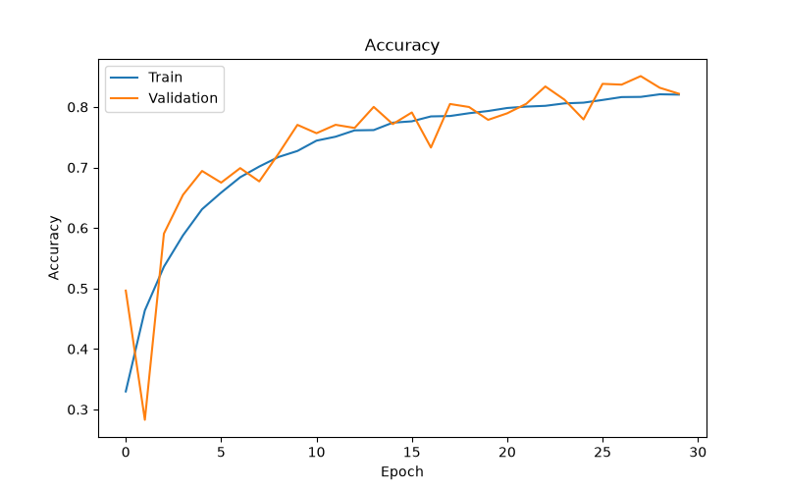
Final Test Accuracy: 82%
Visualizations Included

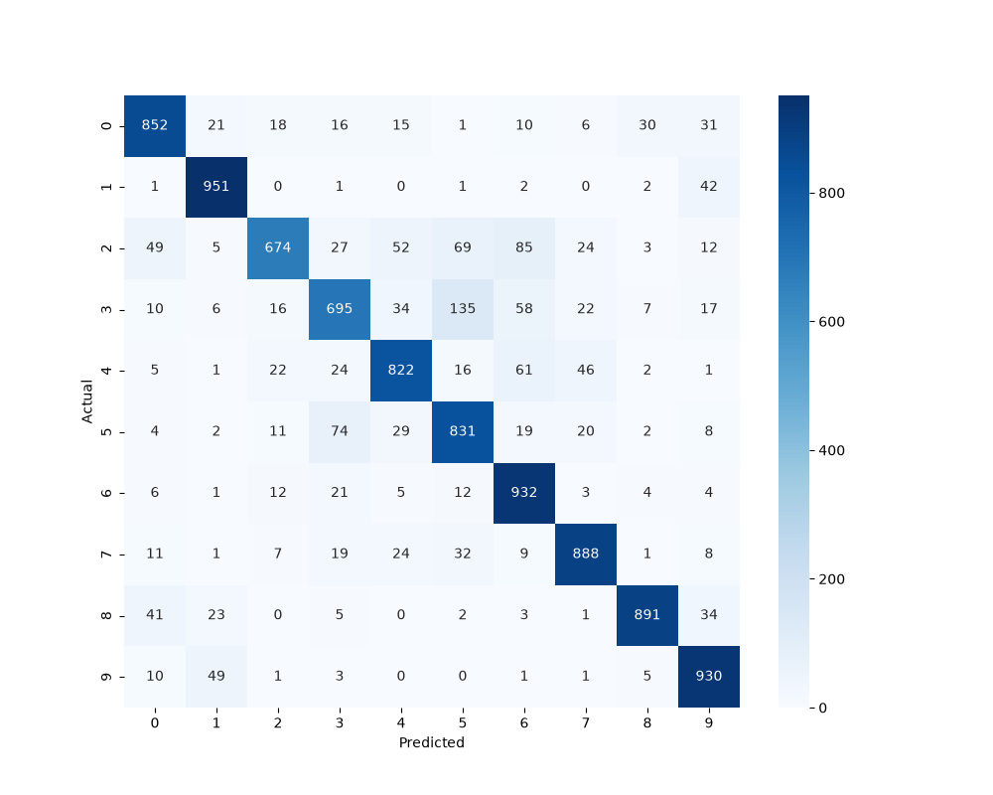
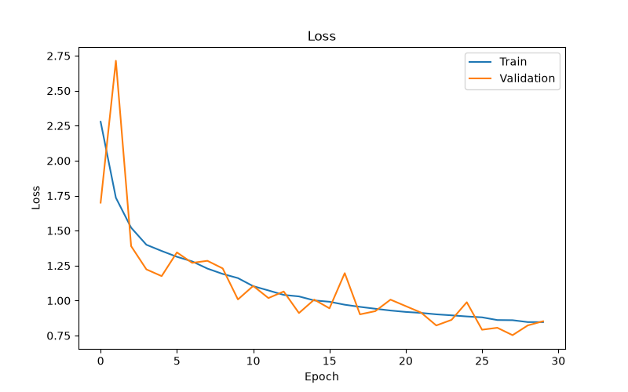
Classification Analysis
The model successfully learned image features and achieved good classification performance on unseen images. Similar classes such as cats and dogs were occasionally misclassified due to visual similarities.

- Challenges and Improvements
Challenges Faced
  - Preventing overfitting
  - Improving model accuracy
  - Handling visually similar classes
  - Selecting an appropriate CNN architecture
  - Balancing training time and performance
Future Improvements
  - Use transfer learning models
  - Train for more epochs
  - Apply learning rate scheduling
  - Use larger datasets
  - Deploy the model as a web application

- Conclusion
An Enhanced Convolutional Neural Network was successfully developed to classify images from the CIFAR-10 dataset. The project demonstrated the complete deep learning pipeline, including data preprocessing, CNN architecture design, model training, and performance evaluation.
Techniques such as data augmentation, batch normalization, dropout, and early stopping improved model generalization and reduced overfitting. The model achieved approximately 82% accuracy, demonstrating effective image classification capabilities.
This project provides a strong foundation in Computer Vision and Deep Learning concepts and can be further extended to real-world applications such as medical imaging, autonomous vehicles, and security systems.

